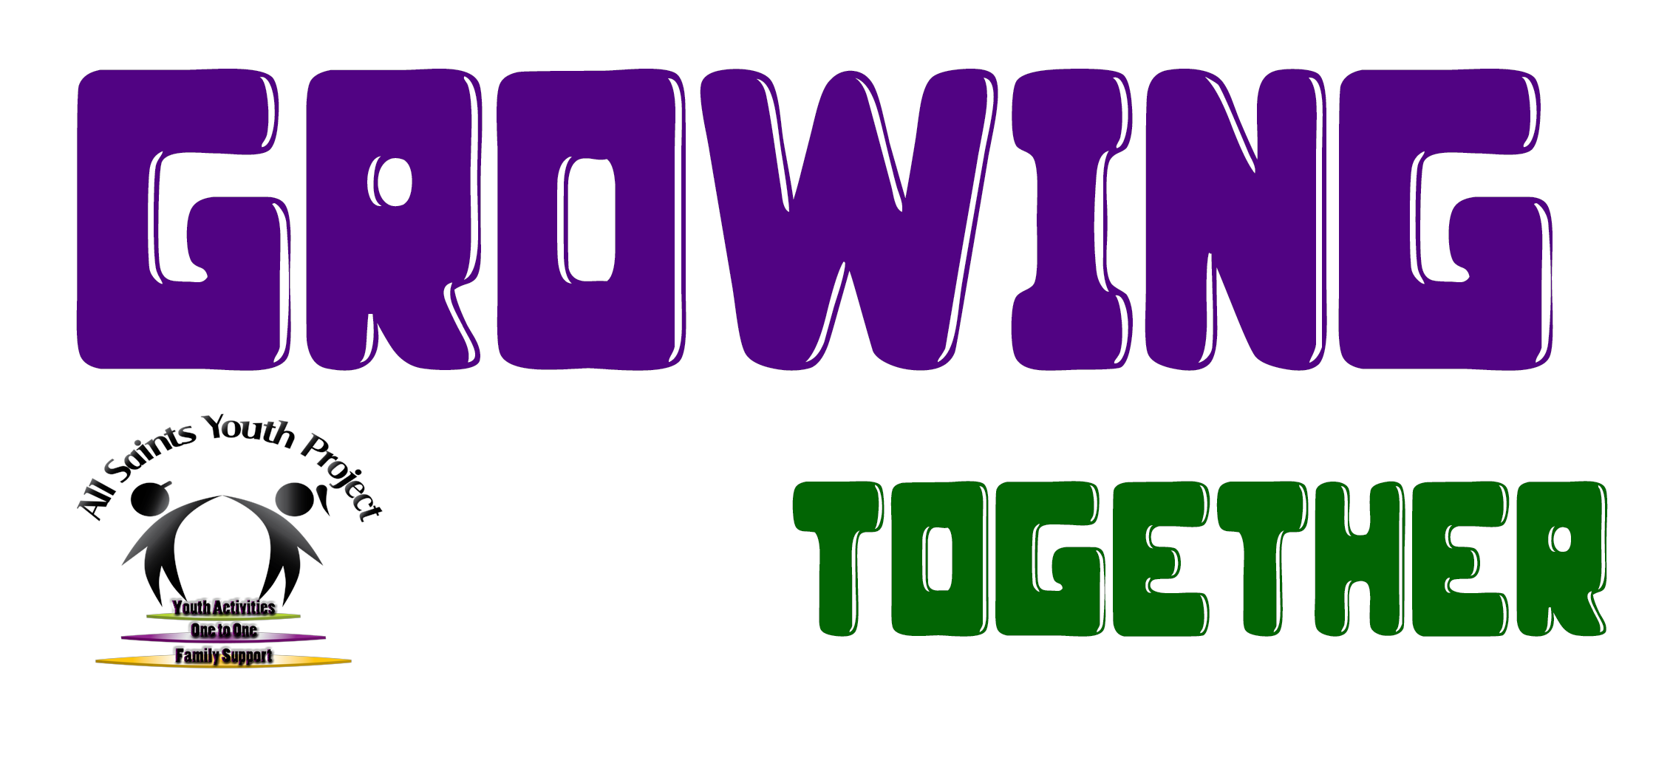

CONTRIBUTE TO THE ARCHIVE.

Thanks for wanting to feature your Youth Club or Organisation on our alphabetical list and be one of our upcoming places in our ‘Featured this Month’ section.
To be included, please answer the following questions about the club or organisation in a short paragraph.

SUPPORTING EACH OTHER…
GROWING TOGETHER.

This project started when a group of our young people here ate All Saints Youth Project in Kings Heath began finding out about our history around the time of our 20th anniversary celebrations. After that, we began speaking to various people who had been involved in youth work for a number of years and, after a visit to the BAYC - where the group saw a an amazing old, hand made “encyclopaedia” of youth services that were around in Birmingham decades ago - they decided to try and create their own everlasting, digital version.

With this in mind, we are reaching out to YOU to add your name, your club and your services to our always growing online archive of Youth Services which are providing such important support and work today.
On the next pages are the prompts for the information we would like you to share.

You are welcome to include any quotes (maybe from young people and/or staff involved in your club?) and pictures that you think best represent the personality of your organisation.

You can either fill in the form and send it back (we have allowed you to download it in various formats), or write your answers in the body of an email- whichever is easier and most convenient for you. You can send any pics as attachments.

If there are any questions you might have, please fell free to contact us.

Thank you.

The details we would like to know are: (please give as much detail as you are able to)

———————————————————————————————————————-

A) What is your club/organisation called and where is it based?

B) When did your club/organisation open and what is it’s mission?

C) What services and support to you offer for Young People?

D) Is there a member of staff or young person who wishes to tell us what your club/organisation means to them and their friends?

———————————————————————————

Please send your completed form or answers, along with any pictures or artwork, to:

m.ford@asyp.org.uk

Once we’ve received it all, we’ll let you know the you can see your club or organisation featured.

Thank you for helping this project by young people at All Saints Youth Project grow!

